WIT-Engage Hackathon

Job – Search Web Application

This full stack web application is a job-search application for blue-collared workers post pandemic.

It is built using –

* Node.js
* Express js (backend)
* HTML handlebars, CSS , JavaScript and jQuery (frontend)
* MongoDb Atlas(cloud-based database)

Functionalities of this application are-

* Search job on the basis of category and location
* List all the jobs
* Recruiters can post the job using this application
* Apply for the specific job

Structure of application-

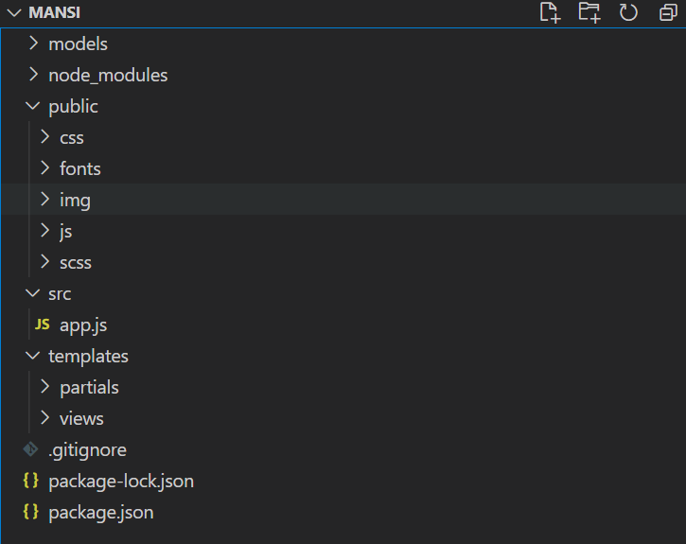



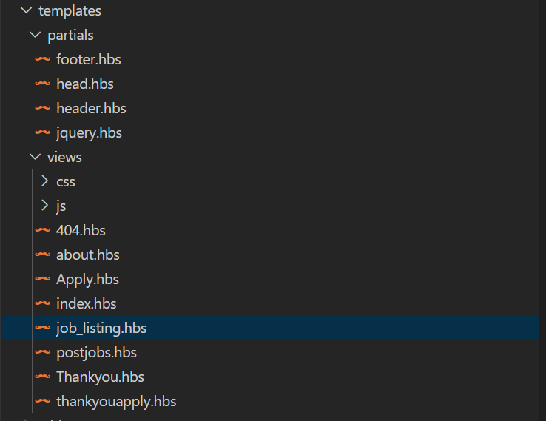

How to start-

1. Go to directory ../Mansi/src
2. cmd command nodemon app.js
3. server started at localhost://3000